Detectable Warning Pavers

Product Diagram – In Line

Raised Concrete
Truncated dome .2” High
2.35”

2.35”

.45” Top Diameter

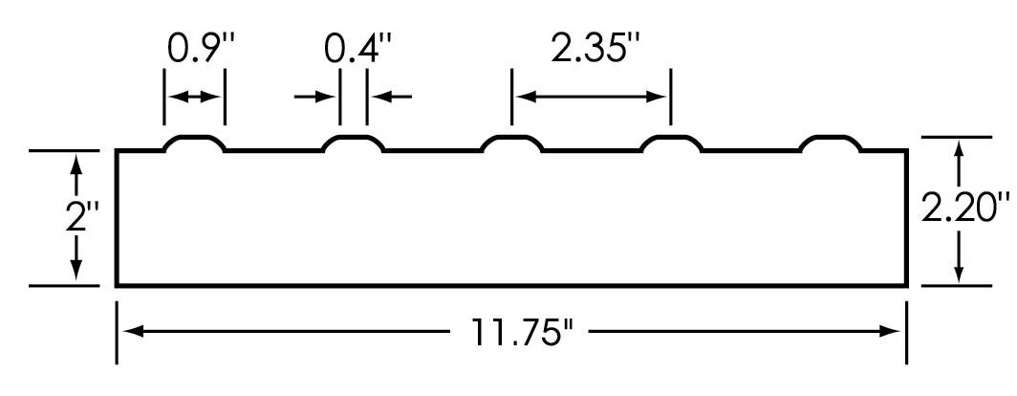
.90” Base Diameter

Standard Sizes: 12” x 12” x 2”

Standard Colors: Yellow
Charcoal
Red
Natural
Custom colors & sizes are also available.

