Detectable Warning Pavers
Installation Diagrams

- SAND SET INSTALLATION
A. OVER COMPACTED AGGREGATE BASE
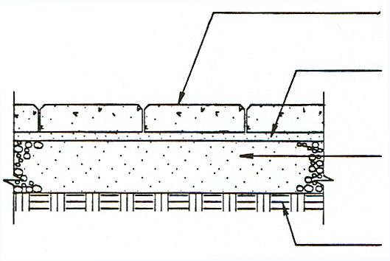
Detectable Warning Pavers 2“ thick
Approx. 1”(25mm) Bedding Sand / Cement

Compacted Aggregate Base
6” (150mm) thick
Compacted Soil Sub-grade

NOTES:
- Drain may be necessary in slow draining sub-grade.
- Base thickness varies with traffic, climate & sub-grade conditions.
- Concrete Pavers should be placed on a cement treated base if soil is extremely weak or constantly saturated.
- Plastic, steel aluminum, or precast concrete edging may be used.
- Joints should be swept with sand.

Detectable Warning Pavers
Installation Diagrams

- SAND SET INSTALLATION
C. OVER EXISTING CONCRETE
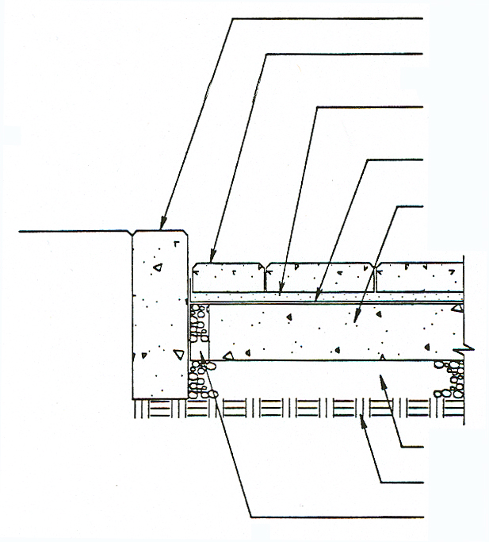
Existing Concrete Curb

Detectable Warning Pavers 2“ thick
1” (25mm) Bedding Sand

Geotextile over concrete. Turn up at curb

Existing Concrete Pavement

Existing Aggregate Base

Existing Soil Sub-grade

2” (50mm) Dia. Drain Hole. Located at lowest elevations. Filled with Pea Gravel

NOTES:
- Existing asphalt or concrete pavement shall be thoroughly inspected for areas in need of patching or replacement. Conduct all repairs and fill all cracks greater than ¼” (7mm) wide prior to placing Geotextile, sand & pavers.
- Provide drainage of sand layer through pea gravel-filled weep holes(s) or catch basin.
- Joints should be swept with sand.

Detectable Warning Pavers
Installation Diagrams

- SAND SET INSTALLATION
B. OVER EXISTING ASPHALT

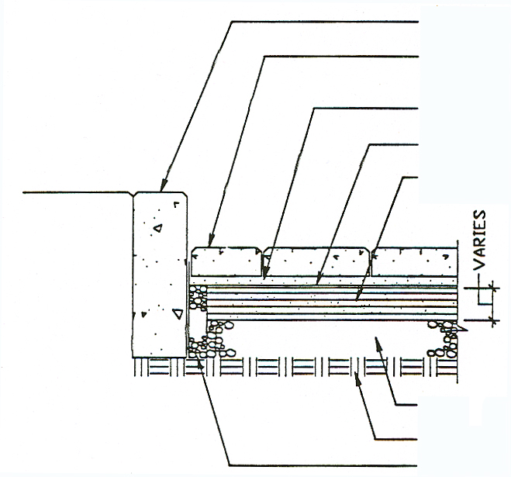
1” (25mm) Bedding Sand

Existing Aggregate Base

Concrete Curb & Foundation (Local standards)

Detectable Warning Pavers 2” thick
Geotextile

Existing Asphalt Pavement

Existing Soil Sub-grade

2” (50mm) Dia. Hole Filled With Pea Gravel Located at lowest elevations

NOTES:
- Existing asphalt or concrete pavement shall be thoroughly inspected for areas in need of patching or replacement. Conduct all repairs and fill all cracks greater than ¼” (7mm) wide prior to placing Geotextile, sand & pavers.
- Provide drainage of sand layer through pea gravel-filled weep holes(s)
- Joints should be swept with sand.

Detectable Warning Pavers
Installation Diagrams

2. MORTAR SET INSTALLATION
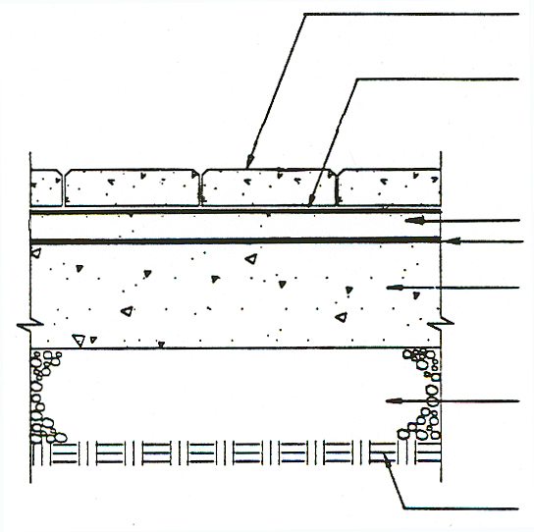
B. THICK SET (BONDED) OVER CONCRETE
Detectable Warning Pavers 2“ thick
Bond Coat

1” (25mm) Mortar Bed

Existing Soil Sub-grade

Mortar Bed Bond Coat

Concrete Slab 4” (100mm) thick

Compacted Aggregate Base 6”(150mm) thick

NOTES:
- Concrete slab shall be sloped to provide complete surface drainage. Provide subsurface drainage as required.
- Slab to have steel trowel and fine broom finish. Do not use curing compounds. Maximum variation in the slab ¼” in 10’.
- Expansion joints are mandatory. Architect must specify location and details on drawings.
- This method is not recommended where the mortar bed is subjected to freeze thaw cycles.
- Joints should be swept with sand or grouted.

Detectable Warning Pavers
Installation Diagrams

2. MORTAR SET INSTALLATION
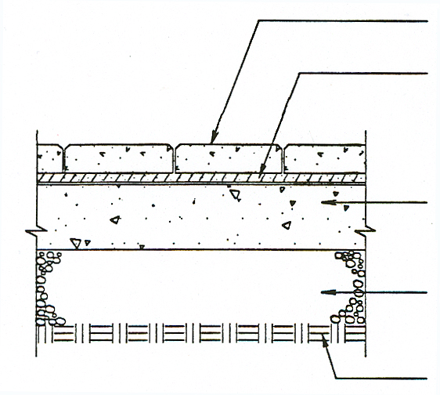
A. THIN SET OVER CONCRETE
Detectable Warning Pavers 2“ thick.
Concrete Slab 4” (100mm) thick

Compacted Aggregate Base 6”(150mm) thick

Existing Soil Sub-grade

Latex Thin Set mortar bed spread per manufacturers recommendation

NOTES:
- Concrete slab shall be sloped to provide complete surface drainage. Provide subsurface drainage as required.
- Slab to have steel trowel and fine broom finish. Do not use curing compounds. Maximum variation in the slab ¼” in 10’.
- Expansion joints are mandatory. Architect must specify location and details on drawings.
- Joints should be swept with sand or grout.

